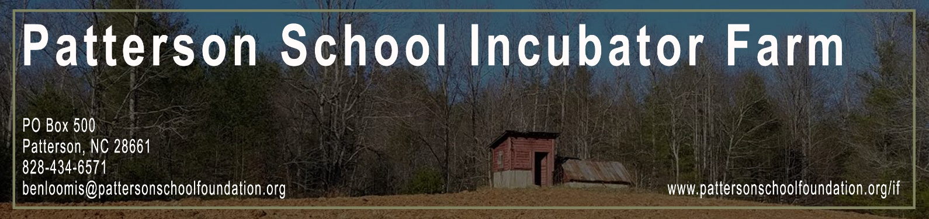
Incubator Farm Application
Thank you for interest in working with the Patterson School Incubator Farm. We are currently leasing housing, land, and commercial kitchen space for the 2017 and 2018 growing seasons. After your application has been reviewed, someone will contact you to discuss your plans and schedule a tour of the property. Patterson also hosts K-12 students from local public schools on a weekly basis, all applicants will be required to pass a background check.

Name: Phone Number: Email Address:
Preferred method of contact:
Please check the aspects of the Incubator Farm that you are interested in:
☐ Incubator Farm Program - $1,000 / year. Includes ½ acre plot, access to equipment, all farm classes and workshops, commercial kitchen time, and hands-on support from on-site Farm Manager. Scholarships available.

☐ ½ Acre Land Lease - $200 / ½ acre. Minimum 3 month lease. Farmers must provide equipment and all other resources. Select from available plots. Farmers must use only organic methods.

☐ Bedroom Lease - $250 / month. Available monthly, April-December, or April-April. Leasing through the 2018 growing season. Bedrooms are approximately 12’ x 15’ and come furnished. Includes water and electricity.

☐ Kitchen Usage - $15 / hour. Certified commercial kitchen approved for food business use. Renters must have Content Insurance, and Liability Insurance with Patterson School Foundation as additionally insured by policy. Kitchen rentals must include 1 hour for cleaning and sanitizing.

☐ Teach a farm class/workshop at PSIF - Interested instructors should submit a description of the course you would like to teach and any necessary requirements below.

Fully describe your plans and how Patterson can help. If you are applying for a scholarship to the Incubator Farm program, please describe your financial need:
Click here to enter text.

How many years of experience do you have as a farmer/food professional?
Click here to enter text.

Date available to start: Click here to enter text.

Any other information (links, personal bio, questions, etc.)

Thank you!
Someone from the Incubator Farm will be in touch with you shortly. For more information, check out www.pattersonschoolfoundation.org/if or contact Farm Manager Ian Driscoll for a tour at 828-713-5916 or at iandriscoll@pattersonschoolfoundation.org. Thanks again, let’s have a great season!

